<https://github.com/jason3375/IS-217/tree/master/Exam>

Home Page

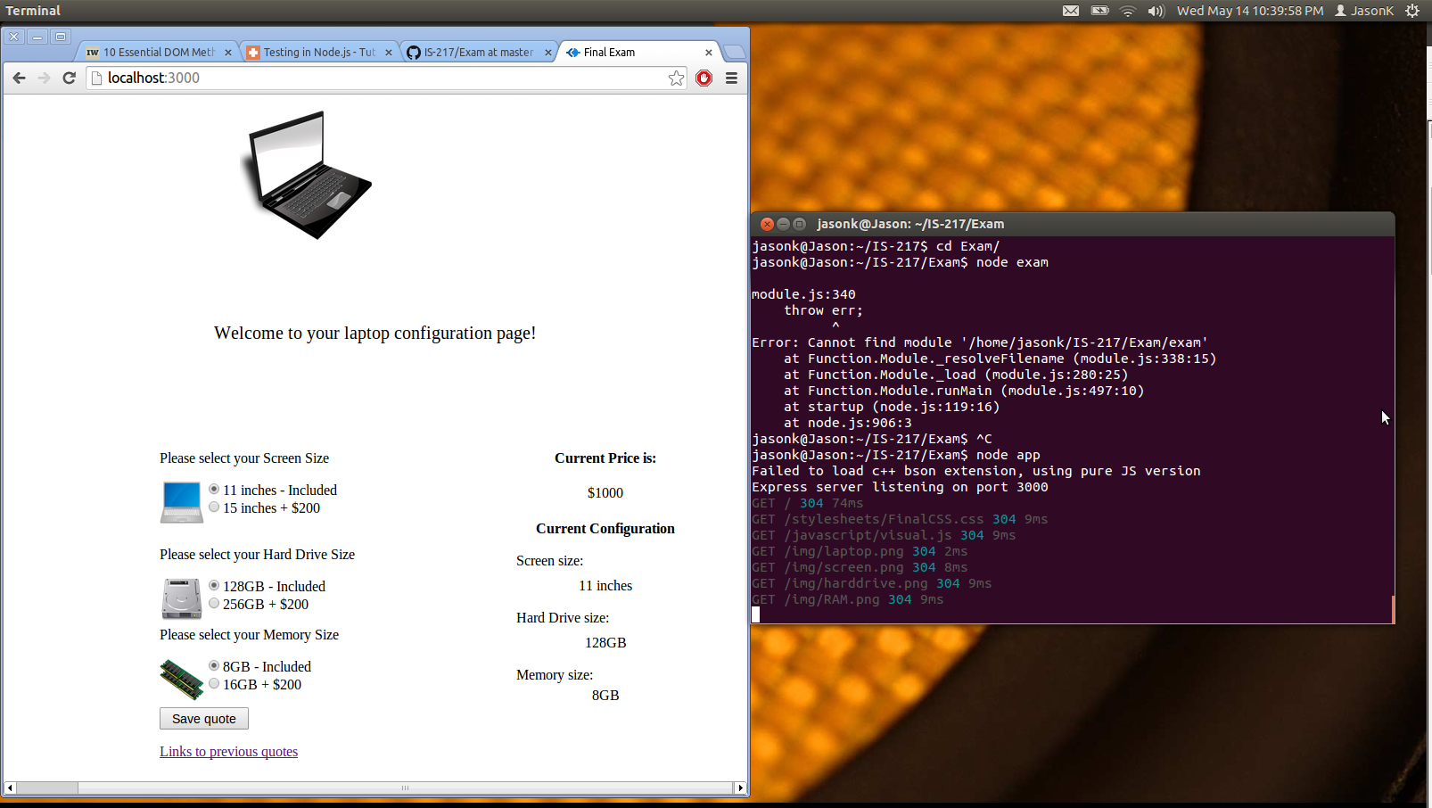

When buttons are clicked the current configuration updates as well as the price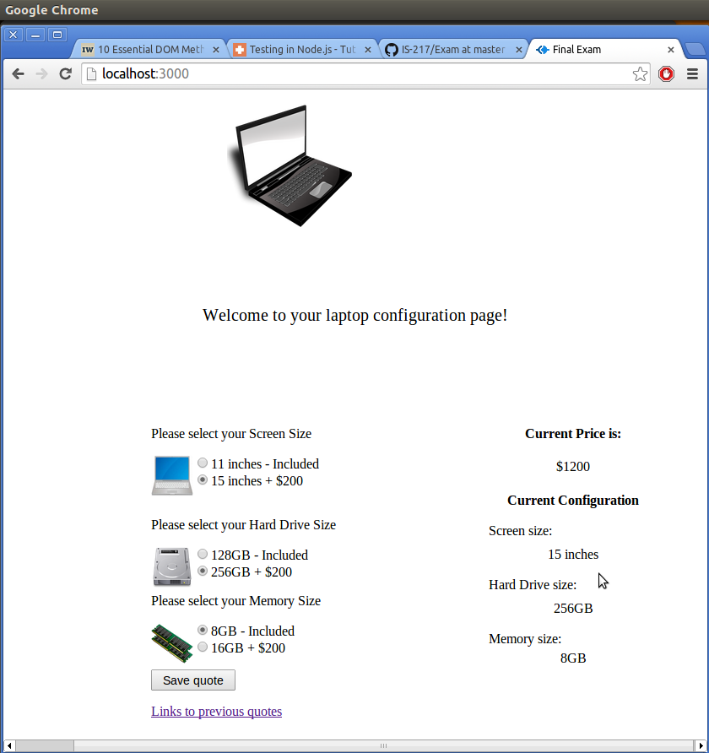

After hitting save you can see that the data gets posted and the page resets back to its original values

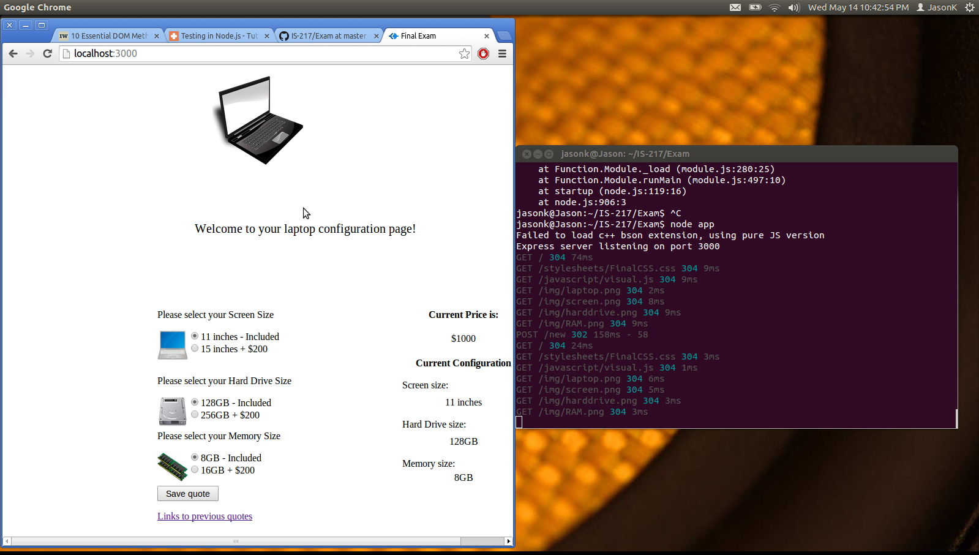

page that has all the other previous quotes on there

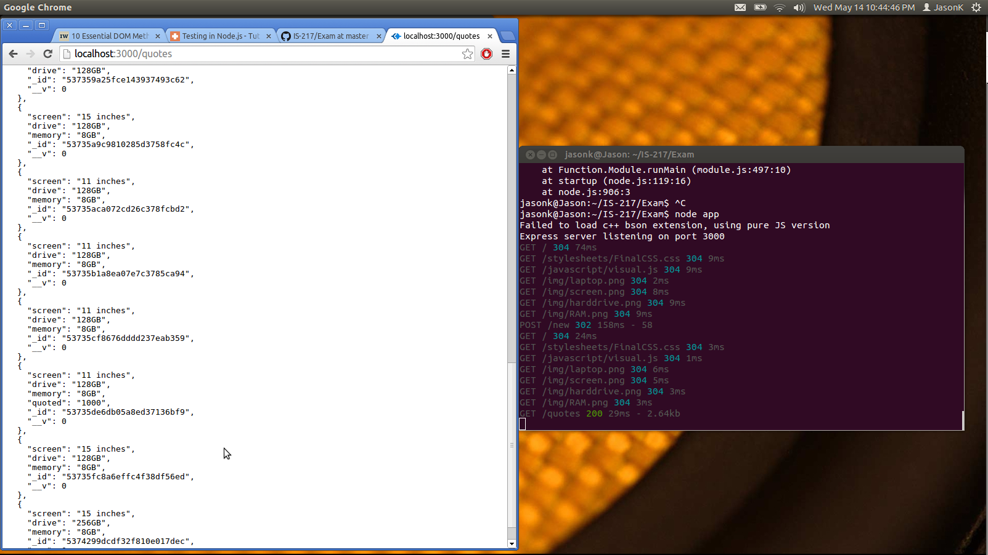

unit test

